Which of the following possesses high polarity?
A. H – I
B. H – Br
C. H – Cl
D. H – F
ANSWER: D
Which of the following molecules has a 1.85 D dipole moment?
A. $HCl$
B. $CO$
C. $CO_{2}$
D. $H_{2}O$
ANSWER: D
The structure of a tri-atomic molecule whose dipole moment is zero will be
A. Angular
B. Linear
C. Complex
D. Spherical
ANSWER: B
Dipole moments are measured in SI units in
A. Coulomb-meter
B. Joule-meter
C. Joule
D. Poise
ANSWER: A
The dipole moment of $CS_{2}$ is
A. 0.00
B. 1.03
C. 1.78
D. 2.05
ANSWER: A
The dipole moment of $CH_{3}Cl$ is
A. 2.00
B. 1.03
C. 1.45
D. 2.05
ANSWER: C
If you have two different polar di-atomic molecules, their dipole moment will be
A. Equal
B. Different
C. Zero
D. Less than zero
ANSWER: B

Which of the following has the highest dipole moment?
A. $CO_{2}$
B. $HI$
C. $H_{2}​O$
D. $SO_{2}$​
ANSWER: C

Dipole moment is highest for :
A. $CHCl_{3}​$
B. $CH_{4}​$
C. $CHF_{3}$​

D. $CCl_{4}​$
ANSWER: C

Symmetrical triangular planar molecules are:
A. $BF_{3}$
B. $CH_{4}$
C. $AlCl_{3}$
D. Both A & B
ANSWER: D

It has zero dipole moment.
A. $CO_{2}$
B. $CO$
C. $CS_{2}$
D. All of these
ANSWER: D

The percentage of ionic character of the bond between two atoms is calculated from the difference between their
A. ionic radii
B. electronegativity
C. electron affinities
D. ionisation energies
ANSWER: B

Which of the following is not correct for dipole moment?
A. lone pair of electrons present on the central atom can give rise to the dipole moment
B. the dipole moment is a vector quantity
C. $CO_{2}$ molecule has no dipole moment since C-O bonds are nonpolar
D. the difference in electronegativities of combining atoms can lead to the dipole moment
ANSWER: C

If the water molecule is linear
A. it would have a very high boiling point
B. it would be highly reactive
C. its dipole moment would be zero
D. it would be highly ionic
ANSWER: C

Which type of bond needs to be broken for magnesium oxide to melt?
A. Co-ordinate
B. Covalent
C. Ionic
D. Metallic
ANSWER: C
Which of the following is non-polar?
A. 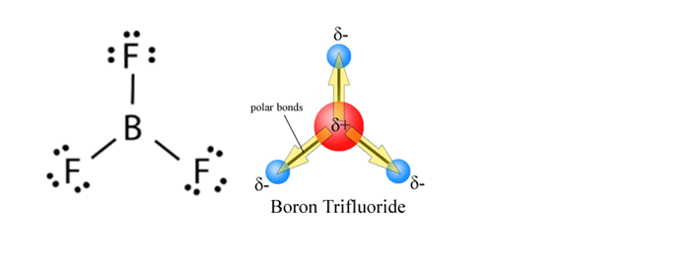
B. 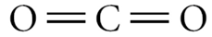
C. 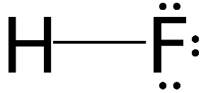
D. 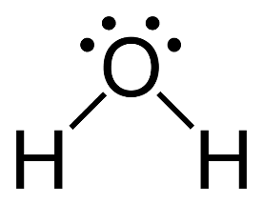
ANSWER: A
Why is the boiling point of methane greater than that of neon?
A. A molecule of methane has a greater mass than a molecule of neon
B. A molecule of methane has more electrons than a molecule of neon
C. Molecules of methane have stronger intermolecular forces than those of neon
D. Molecules of methane from hydrogen bonds, but those of neon does not.
ANSWER: C
Among the following, the maximum covalent character is shown by the compound.
A. $MgCl_{2}$
B. $FeCl_{2}$
C. $SnCl_{2}$
D. $AlCl_{3}$
ANSWER: D

